ISE 4442/5442: Augmented and Virtual Reality STUDENT ID G00898874

Instructor: Vijitashwa Pandey STUDENT NAME Jared Teller Homework 3: Due date 11/29/2024, 11:59 PM Electronically UNDERGRADUATE/GRADUATE? Graduate

* *Please answer in* ***your own words*** *and* ***cite your sources,*** *if applicable.*
* *Provide the project files in a zipped format and/or upload to GitHub and reference it in your submission*
  1. Complete the HOQ for the speech transcription project by adding a few more functional requirements, matching CNs to FRs, correlations or competitor information (20 points).

**See github document in the following repository:**

[**https://github.com/TellerOU/AR-Transcription-Project**](https://github.com/TellerOU/AR-Transcription-Project)

**HOQ_Transcription.xlxs**

* 1. Add functionality to the existing speech transcription project by adding at least one of the following (20 points):
     1. **Text sanitation and appending new text to already existing text.**
     2. **Make the project work on the HTC Vive.**
        + **See the result on Github in the VIVE_Files folder.**
        + **I chose to port this into an HTC Vive level and then add some functionality.**

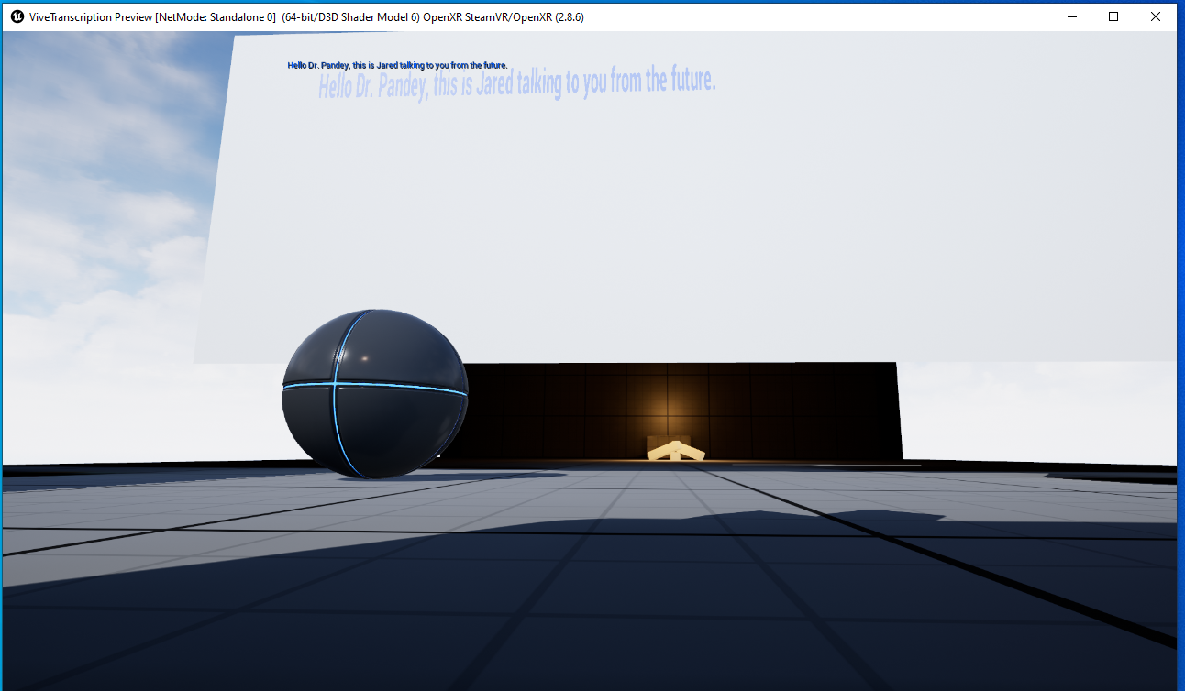

* + 1. ~~Package the project as an app.~~

**And** one of the following (40 points)

1. ~~Make text box move with the headset.~~
2. **Scrolling feature in the textbox. TPODODODODODODODODO**
   * **I chose to add the scrolling feature in the textbox. This can be found in the same github as above and here are some screenshots of it working.**

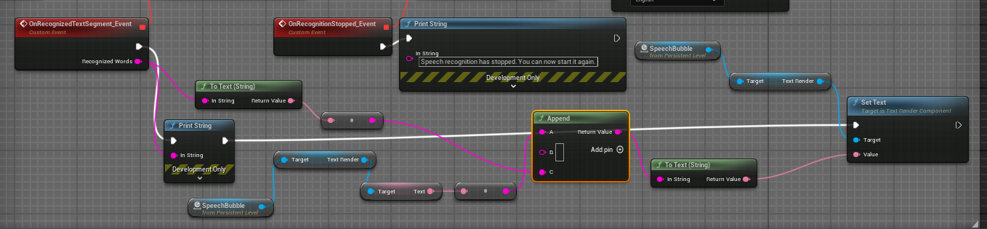

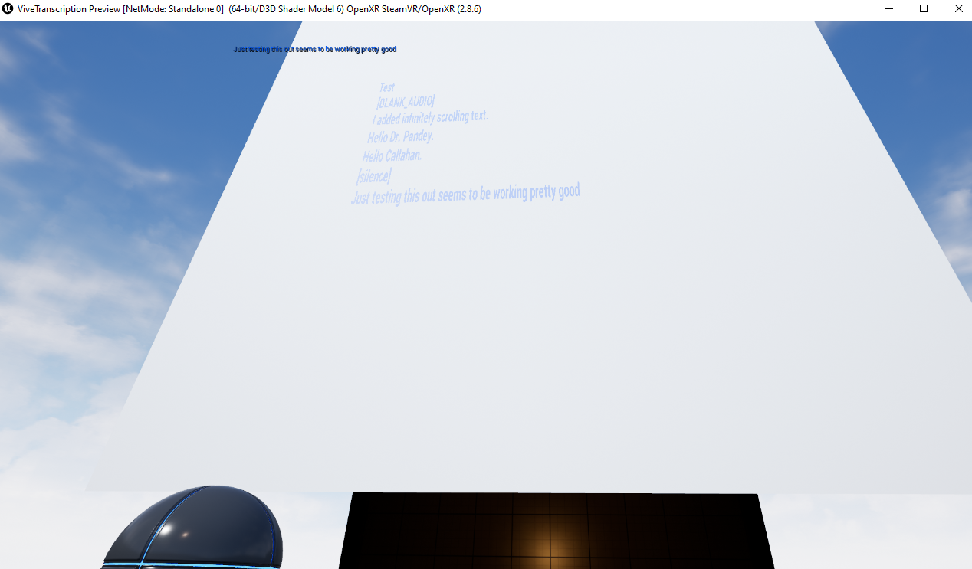

1. ~~Language translation.~~
2. ~~Add a menu that has a slider and a button (for example, add a button that changes the text background color).~~
   1. Add a custom functionality to an asset in the manufacturing project done in class (20 points).
      1. See this on Github at: <https://github.com/TellerOU/Manufacturing-Project-ISE5442>
      2. **I added a trash can that deletes the grabbed objects as you throw them in by checking for a collision with its physics properties, and then destroying the actor and playing a fire sound effect. Now we can play basketball with the spawned cubes.**

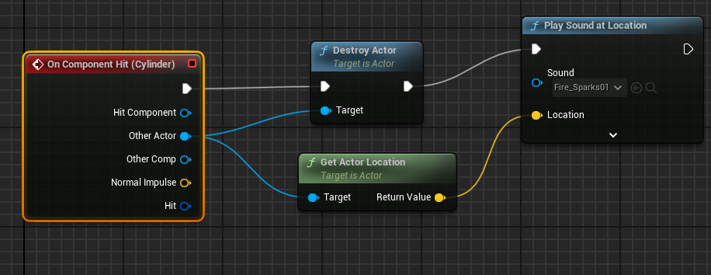

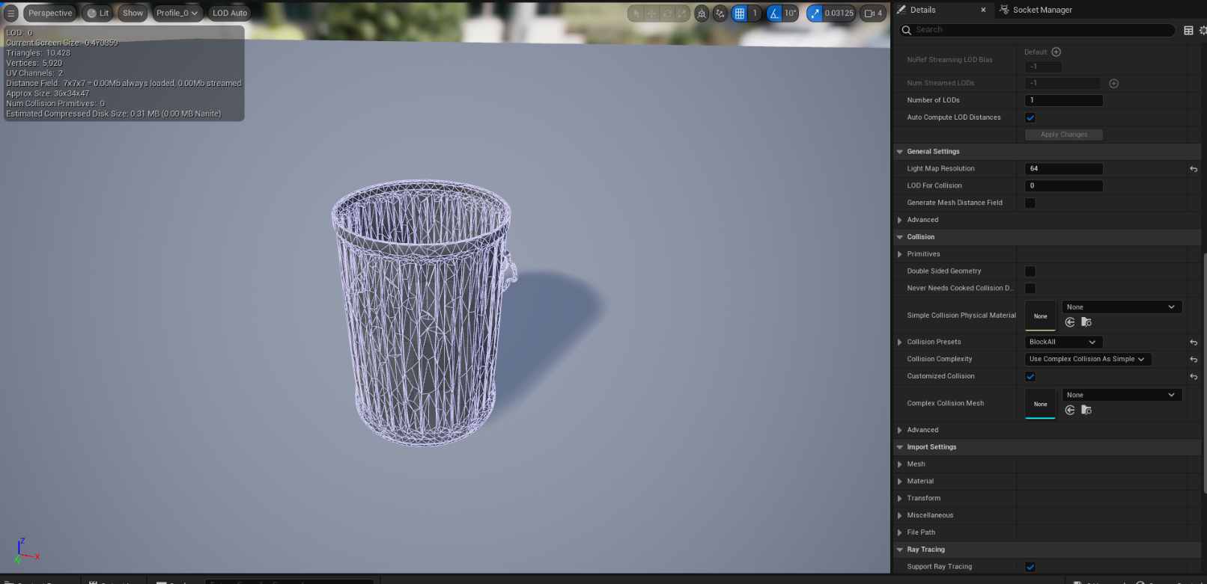

Page **1** of **1**